- Purpose:

The purpose of this procedure is to describe how to swab test equipment that has been used to produce and package scented salt and verify that the equipment is free of residual fragrance.

- Scope:

This procedure applies to all product change overs from fragrance to USP product.

- Responsibility:

Repackaging production employee is responsible for collecting swab samples from cleaned equipment and a Quality Associate or a certified Quality representative is responsible for performing the TLC analysis.

- Safety Considerations:

Latex gloves, safety glasses, and standard safety attire for the area. Individuals that are sensitive to scented salt product must inform their supervisor.

Safety is a condition of employment. Employees are not authorized to work in an unsafe manner and are prohibited from harming the environment of the facility or community.

- Materials/Equipment:
- Latex or Nitrile gloves
- Swabs
- Resealable Swab Sample Bags
- TLC Silica Gel 60 F₂₅₄ (10 x 20 cm) Plate – or equivalent
- Ruler (w/ centimeter demarcations)
- Pencil (DO NOT use a pen or marker)
- Isopropyl Alcohol (IPA)
- UV Light
- 10uL pipettes
- Plastic LureLock Syringe
- Sample of Salt that was run
- Balance
- Test Tubes
- Test Tube Rack
- Cyclohexane
- Scissors or spatula
- Sampling Procedure:

- Wear gloves to ensure no cross contamination.
- Remove clean swab from packaging.
- Roll swab several times over the area to be sampled. (Note: Sample areas can be found on the Swab Test checklists (R12-PR-100-F015a, b, c, or e) located on the DOC system.)
- After adequately swabbing sample surface, place the swab in a zip-lock bag and label with the sampling location.
- After all samples have been taken and labeled, wash hands thoroughly with soap and water then give the bags to either a Quality Associate or certified representative.

- Testing Procedure:

Note: Always wear gloves when handling a TLC plate as the oils on your hands will cause stains and interfere with your results. Also, TLC plates are VERY delicate so be sure to handle with care. Do not use plates if there are major scratches or cracks present. Never reuse any TLC plates.

- Prepare your samples by adding 5 mL of IPA into each of your test tubes. Place your swabs into their own individual test tubes with sampled side down and stir them vigorously to ensure any oils that may have been picked up will be dispersed into solution.
- Prepare your standard by putting 5 mg of the scented salt into a test tube.
- To your standard add 10 mL of IPA and mix well. (Note: The salt does not need to be dissolved as we are only concerned with the oils on the surface.)
- Prepare your plate by taking your ruler and measuring 1 cm from the bottom edge and LIGHTLY drawing a straight line across the length of the plate.
- Using scissors or a spatula, score the plate 1 cm from the top and continue across the entire length.
- Label the top of the TLC plate with the date and machine ID.
- Lightly draw small evenly placed circles or tick marks, equal to the number of locations to be tested + 1 for the standard, on top of the pencil line that was drawn in step 4.
- Using your 10uL pipette gently spot each mark with 10uL of each sample and standard. (Note: Keep your spots as small and tight as possible to ensure that the samples do not overlap. It may be helpful to deliver the 10uL in small step-by-step stages. See diagram below for an example.)
- Allow spots to dry completely before proceeding.
- Add ~ 0.5 cm of Cyclohexane to the TLC tank and gently place the plate in the tank and cover. (Note: Do not allow the mobile phase to touch or cover the spots. Cyclohexane is hazardous and must be disposed of in a proper manner.)
- Once the mobile phase reaches the score line, remove the plate from the tank and allow the plate to air dry.
- View the plate under a black light, the standard spot should appear as a dark purple color. If any other spots are present, this indicates that fragrance is present and the equipment needs to be cleaned again.
- If there is a positive result, the machine must be re-cleaned and the procedure must be repeated until ALL swabs test negative for fragrance.
- Record results on corresponding checklist and turn both the plate and the checklist into Quality for retention purposes.

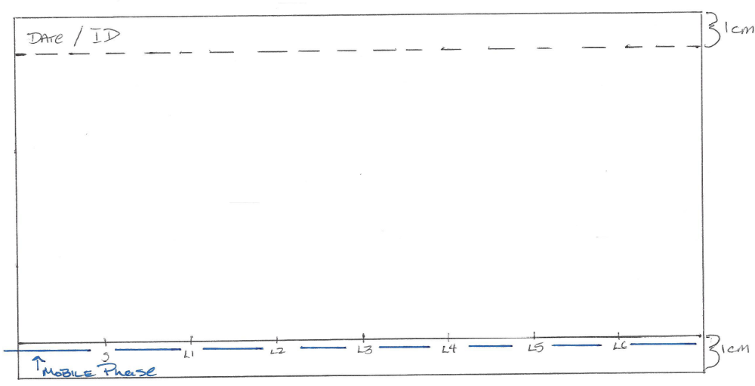
Example of TLC plate

- Reference Documents:

Swab Test Auto Line (R12-PR-100-F015a)
Swab Test Manual Line (R12-PR-100-F015b)
Swab Test Carton Line (R12-PR-100-F015c)
Swab Test Auto Line #3 (R12-PR-100-F015e)

- Change Information:

Combined and updated SOPs Swabbing after Scented Salt (R12-PR-100-015) and Scented Salt Sanitation using Thin Layer Chromatography.

